It focused on developing the backend infrastructure of the EduGenie Learning Assistant using the FastAPI framework. In this activity, RESTful API endpoints were created for each educational functionality so that the frontend interface could communicate efficiently with the AI-powered backend modules. FastAPI was selected because of its high performance, asynchronous request handling, simplicity, and easy API integration capabilities.
The backend architecture was designed in a modular manner, where each endpoint was connected to its respective AI functionality. Separate API routes were developed for Question Answering, Concept Explanation, Quiz Generation, Summarization, and Personalized Learning Recommendations. These endpoints handled user requests, processed input data, generated AI-powered outputs, and returned structured JSON responses to the frontend interface.
The following RESTful API endpoints were implemented:
/qa → Handles educational question answering
/explain → Generates simplified explanations for topics
/quiz → Creates AI-generated multiple-choice quizzes
/summarize → Summarizes lengthy educational content
/learn/recommendations → Generates personalized learning paths

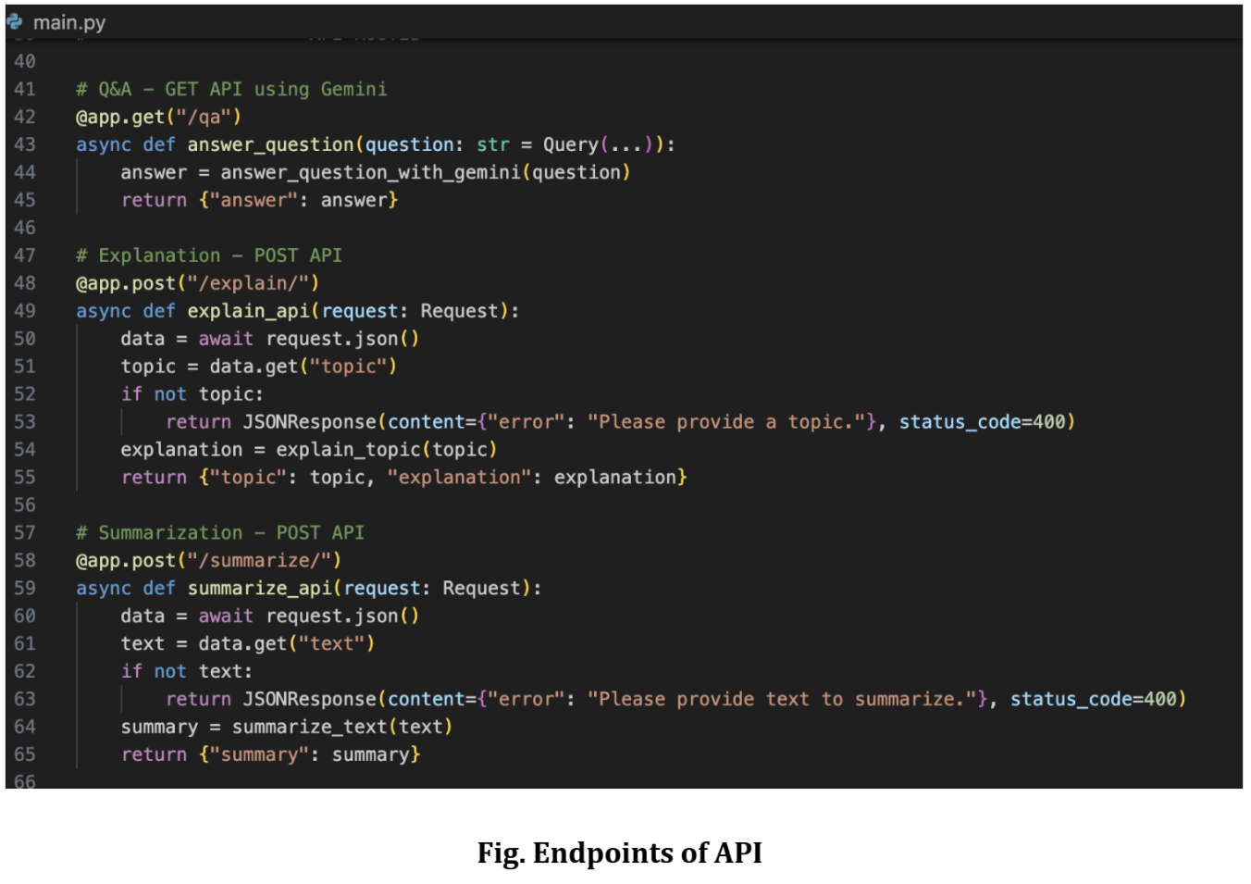
This image shows the implementation of:
Q&A GET API
Explanation POST API
Summarization POST API
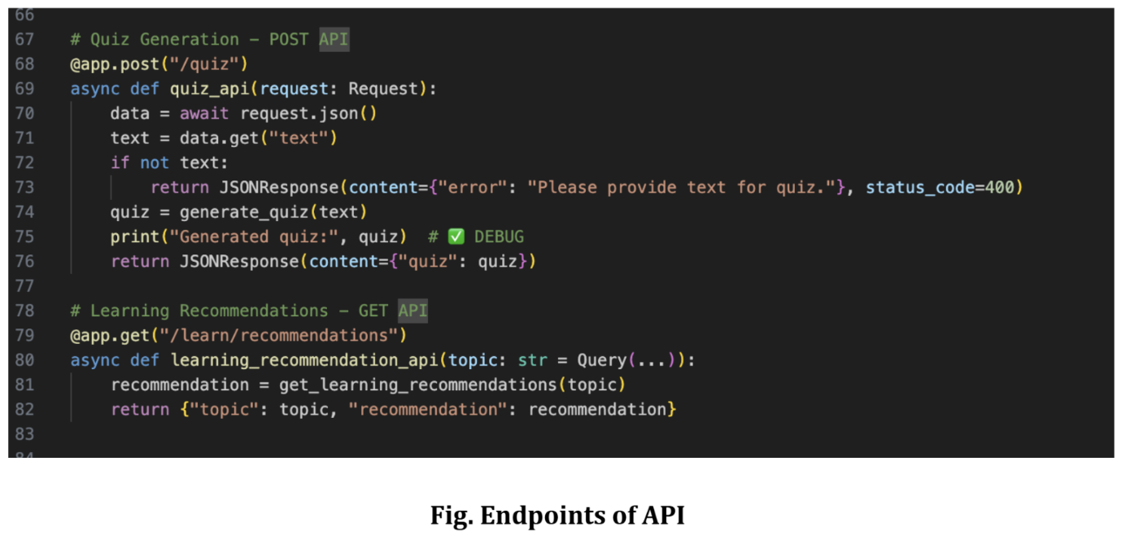
This second image shows the implementation of:
Quiz Generation POST API
Learning Recommendation GET API
Each endpoint receives user input through request parameters or JSON data, validates the input, calls the corresponding module logic, and finally returns the generated educational response in JSON format. Error handling was also implemented to ensure proper validation when required input fields are missing.
This backend API integration established smooth communication between the frontend interface and AI modules, enabling real-time educational assistance and efficient response generation within the EduGenie Learning Assistant.

